DAYDREAMS OF A PASTOR…
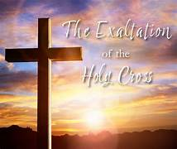
This week we celebrate two important feasts. On September 14th, we celebrate the feast of the Exaltation of the Holy Cross. This feast is celebrated for two reasons: (1) to understand the history of the discovery and recovery of the True Cross and (2) to appreciate better the importance of the symbol and reality of Christ’s sacrificial love.

The Exaltation of the Holy Cross serves as a reminder of the sacrificial love of Christ and his triumph over sin and death through his crucifixion and resurrection. This feast highlights the paradoxical nature of the cross - an instrument of suffering transformed into a symbol of triumph and redemption.

The Exaltation of the Holy Cross holds a special place in our hearts as it captures the core message of Christianity – the transformative power of selfless love and the ultimate triumph of light over darkness. It serves as a reminder of the lengths to which God's love goes to redeem humanity and offers a chance for us to draw strength, inspiration, and spiritual renewal from the symbol of the cross.

On September 15th we honor our Lady of Sorrows, a powerful reminder of the unwavering faith and love of the Blessed Virgin Mary. We remember her spiritual martyrdom, and her compassion with the sufferings of her Divine Son, Jesus. As we reflect on her seven sorrows this week, we remember the immense pain she endured as the mother of Jesus. Despite the sword of sorrow that pierced her heart, Mary remained steadfast in faith and trust in God. She stood at the foot of the cross, witnessing her Son’s suffering and death, yet she never wavered in her devotion.

Let us embrace the cross in our lives, finding hope and redemption in the sacrificial love of Christ and challenge us to find meaning in our own crosses. Let us embrace Mary’s sorrows, that helps us face difficulties with faithfulness and love.

May the cross be a constant reminder of God’s boundless love.

Fr. Roy Parayil, M.S.

FEAST OF OUR LADY OF LA SALETTE


The feast will be celebrated with 9 days of Novena from September 12th – 20th. The Novena will be offered after each Mass.
On the 20th of September, on the 9th day of the novena, we will celebrate the Feast of Our Lady of La Salette.

Lunch with Fr. John in the Church Hall on September 20th after 11am Mass.

As we celebrate the 180th Anniversary of La Salette Apparition, we also thank Fr. John E. Welch, M.S. for his 29 years of ministry at St. James Church.

Please join us in celebrating the feast, appreciating Fr. John for his love and ministry, and wishing him all the best as he moves to La Salette Retirement House in Hartford on October 01, 2026.
Fr. Roy Parayil, M.S.

TWENTY-FOURTH SUNDAY IN ORDINARY TIME

First Reading: Sirach 27:30—28:7
Sirach advises all to forgive the faults of their neighbor. Only by forgiving the sins of others, can a person expect to be forgiven his sins.

Second Reading: Romans 14:7-9
Paul stresses that no one is his own master; we are responsible to the Lord, and we belong to him in both life and death.

Gospel: Matthew 18:21-35
This narrative points out the difference between mercy and justice. When Peter asks how often he should forgive someone who wrongs him, Jesus answers, “…not seven times: I say seventy times seven times.” Jesus then narrates the story of the king who was merciful to his official by forgiving him all his debts, but this same official showed no mercy to his own servant.

Schedule for September 19th and September 20, 2026
4:30PM 7:00AM
E. Minister: Ernie & Diane Charron John Lupien
Julie Dupont
Lector: Phyllis Morrison Julie Dupont

9:00AM 11:00AM
E. Minister: Bev Richardson John Brady
Marilyn Streb Michelle Brady
Lector: Adam Brindamour Laurie Barrette

UP-COMING EVENTS FOR 2026 – ST. JAMES CHURCH
(Please add to your calendar)
LA SALETTE NOVENA AND FEAST: September 12 - 20, 2026
BLESSING OF THE ANIMALS: October 3, 2026 - 11 am (Parking Lot, K of C)
4rd ANNIVERSARY – FR. JOHN: October 11, 2026
OCTOBER 17 &18 – Gifts from Jerusalem on display after the masses.
CONFIRMATION: October 28, 2026 – 7 pm.
NOVEMBER 1, 2026: Veneration of Saints’ Relics, 7 am to 12 pm.
FIFTH SUNDAY ROSARY: November 29, 2026, After the 9 am mass.
BREAKFAST WITH SANTA: December 05, 2026
CHRISTMAS LIGHTS – Pilgrimage to La Salette: December 12, 2026
CLEANING
CHURCH CLEANING: Volunteers: December 19 - 9am to 12pm.
SUMMER CLEAN UP (OUTSIDE): Mid-November. (K of C)

Phone Numbers of Persons In charge – Please contact
St. James School: Catherine Reed – 860-774-3281
Religious Ed: Mary Chappell – 508-615-1621
Religious Ed: Marcia Bardin – 860-634-3915
OCIA: Bev Richardson – 860-792-8054
K of C: Shawn Whiston – 860-382-5897
Vocation Committee: Dn. Joseph Delaney – 860-319-9536
La Salette Laity: Marcia Bardin -860-634-3915
Altar Servers: Ernest Charron – 860-614-5096
Eucharistic Ministers: Sue Griffiths – 860-774-0321
Lectors: Sue Griffiths/ Ernest Charron - 860-774-0321
/ 860-614-5096

Vigil Lights are burning brightly for a former parishioner, Wanda Ben.

SIGN-UP- SHEET FOR WEEK OF PRAYER AT HOME
The sign-up sheet for a week of prayer at home for vocations is at the main entrance of the church.
We humbly request all families to pray for vocations.
Set aside a few minutes praying for vocations and inspiring our children at home. Please sign-up for a week of prayer. Those who sign up for the weekly prayer will dedicate themselves by praying the Rosary and Vocation Prayer from Sunday through Saturday. Let us continue to pray for an increase of vocations to the Priesthood and Religious life.
9/05-Lisa; 9/20-Cindy; 9/26 -Lisa;10/03-Sisters.

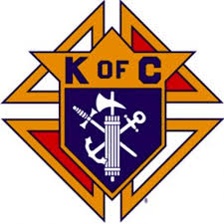
Recruitment – Membership Drive

St. James Parish Knights of Columbus Council #2883
“In Service to ONE. . . In Service to All”
Saturday, September 26, 2026, 4:30PM Mass
Sunday, September 27, 2026, 7, 9, and 11AM Masses
Meet Council members & discuss K of C membership
Free coffee & donuts after the 9:00AM Mass.
Recruitment-Membership Coordinator, Peter Gerardi,
@ (860) 377-1068 or email @ my3sons76@charter.net

MASSES
MONDAY, September 14,
The Exaltation of the Holy Cross
9:00AM Mr. Edward Rozanski…by the Sisters
Souls in Purgatory
TUESDAY, September 15,
Our Lady of Sorrows
9:00AM Departed Souls of the Adoration Sisters
John Gallow, Jr….by his wife, Rita
Debra Lapointe…by family
Pierrette McCartney…1st Anniversary…by Margaret
WEDNESDAY, September 16,
Saints Cornelius, Pope, and Cyprian, Bishop, Martyrs
9:00AM Joseph & Betty Larrow…by family
Michael Gerardi…by Pete Gerardi
THURSDAY, September 17,
Saint Robert Bellamine, Bishop and Doctor of the Church;
Saint Hildegard of Bingen, Virgin Doctor of the Church
9:00AM James and Joan Kent…by family
Peace in our world
FRIDAY, September 18,
9:00AM The Whitaker family …by the Ferland family
The sick of the parish
SATURDAY, September 19,
Saint Januarius, Bishop and Martyr; Blessed Virgin Mary
4:30PM Barbara Gallant Yolda…by John
Pat Integlia…birthday…by Linda
Fr. Tom Sickler…by Paul
SUNDAY, September 20,
THE TWENTY-FIFTH SUNDAY IN ORDINARY TIME
7:00AM Stephen & Anna Szarkowicz…by family
Raymond Methot…by his wife
9:00AM Eugene & Doris Larrow…by family
Dorothy Porter…by Clyde & Barbara Porter
11:00AM Henrique Aguiar…by family
Michael Gerardi…by Peter Gerardi
Clarence & Mona St. Jean…75th Heavenly Anniv…
By their children
LA SALETTE MASSES
In memory of Frederick & Adelyn Bodenschatz
In memory of David & Sophie Horvat, by son, Joseph
In memory of Lawrence & Gloria Clark and Edmond and
Agnes Lefrancois…by daughter

2026 Mass Openings: Mass Intentions: $15.00 each
7:00AM: 10/11; 10/18; 10/25; 11/01; 11/08; 11/15; 11/22; 11/29; 12/06.
9:00AM: 9/21; 9/22; 9/24; 9/29; 9/30; 10/01; 10/02; 10/04; 10/06; 10/08; 10/09; 10/12; 10/13;10/14; 10:15; 10/16;10/19; 10/21; 10/22; 10/23; 10/26; 10/27; 10/28; 10/30;11/02; 11/03;
11:00AM: 9/27; 11/08; 11/15;12/27.

WEEKLY OFFERING . . 8/30 . . . . . . . . . . . . . $5,069.00
WEEKLY OFFERING . . 9/06 . . . . . . . . . . . . . $5,960.00
9/13- St. James Elementary School Campaign;
9/20-School Support.

MARIAN SHRINE ALTAR FLOWER ARRANGEMENT…
The flower arrangement for the Blessed Mother’s Altar is open for the month of September. Please consider having an arrangement for Our Blessed Mother’s Altar in memory of a loved one. 10/10-In memory of Ryan Lefevre, grandson, by Maggie Grenier.

Pilgrimage to the Shrine of Saint Anne with Bishop Reidy and a traditional New England Meal at Publick House Historic Inn, Tuesday, September 15th, Sturbridge, MA. by Deluxe Dattco motorcoach. Cost for the day, is $90 per person. Contact Diocese of Norwich – 860-887-9294 –
Fr. Brian Maxwell, organizer.

PARISH EVENTS
Wednesday – Devotion to the Infant Jesus of Prague Every Wednesday at 8:30AM.
Rosary for Vocations - Tuesdays and Thursdays at 8.30AM.
Wednesday – Bingo every Wednesday night
Men’s Bible Study – Fourth Monday of every Month at 7PM in the Church Hall.
La Salette Laity Classes – Every First Tuesday of the Month at 6PM.
Fifth Sunday Rosary – Fifth Sunday of every month after the 9 am mass
Holy Hour – Every Third Monday of the Month. Next Holy Hour: September 21st at 7pm with rosary at 6:40PM.
Catholic Elementary School Collection
This September 12th and 13th the Annual Catholic Elementary School Collection will be conducted throughout the Diocese. This will be an in-pew collection. Appropriately titled, Faith for the Future, the collection recognizes that our future is dependent upon our children receiving the best education possible. Our 9 Diocesan elementary schools offer families a safe and nurturing environment providing exceptional academic, social and moral growth, preparing our children to become the future leaders of our church and communities.

All funds collected at our parish will stay here for our school. Thank you for helping to ensure the continued success of St. James School. We truly appreciate your support.

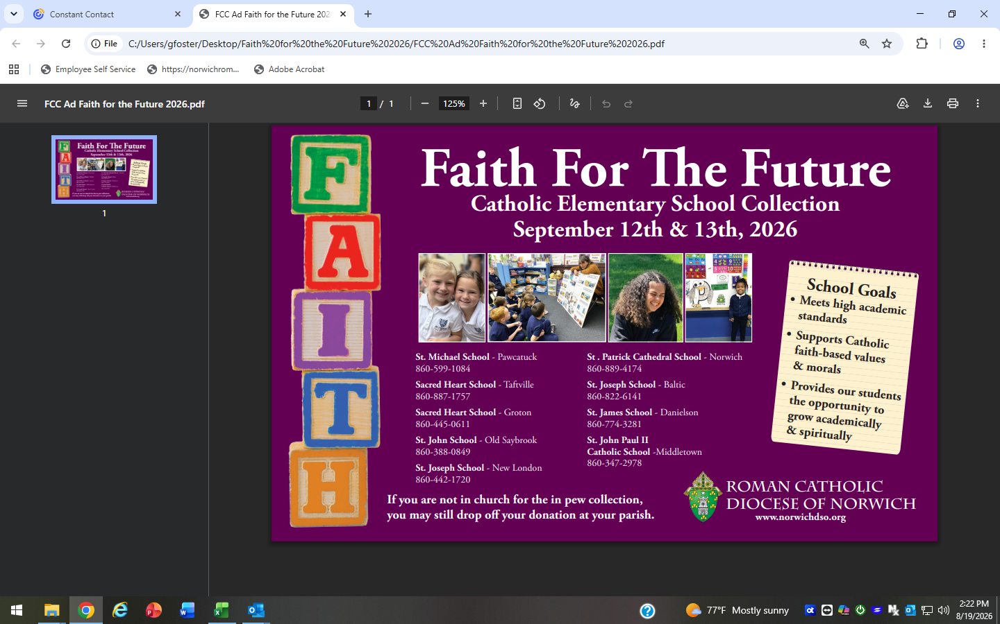

Religious Education
Register now for Religious Education 2026-2027 and be part of St. James Parish community! Classes begin September 20th.

Our Faith Formation Program supports children and families as they grow in faith and become more connected to parish life in a caring and encouraging environment.
Now is the perfect time to sign up and reserve your child’s place for the upcoming year.

Registration forms are at the entrances to the Church, and the forms can be placed in the collection basket.

Welcome – all new and returning students.

AN INVITATION TO ALL…who would like to join the Catholic Church or to receive the Sacraments of Confirmation or Holy Communion as an Adult or a teenager ages 15 to 17. Class begins on Tuesday, September 22, 2026, 7pm – 8:30PM in the church hall. The class is also known as the OCIA. Contact Bev Richardson, @ 860.630.0593.

ST. JAMES SCHOOL – OPENINGS FOR PRE K- GRADE 8; CALL TODAY – 860-774-3281

*FULL DAY PRE K & 4-YEAR-OLD PROGRAMS
*PRE-K – 8 FAITH BASED, MASS ATTENDANCE
*STRONG ACADEMIC PROGRAM
*READING, MATH AND SPEECH INTERVENTION
*FULL TIME NURSE
*WEEKLY SPECIALS: ART, MUSIC, P.E.,
*COMPUTER, SPANISH, LIBRARY
*FINANCIAL AID AVAILABLE
*EXTENDED DAY UNTIL 5:30 PM
*TUTORING AVAILABLE
*TOURS AVAILABLE

TEACHER NEEDED!
Middle School Religion and Social Studies Teacher
Grades 6,7 and 8. To start Immediately!
Send a resume to c.reed@stjamesdanielson.org
Call 860-774-3281

FEAST OF OUR LADY OF LA SALETTE
Prayer for the 180th Anniversary La Salette Apparition (1846-2026)
Our Lady of La Salette, reconciler of sinners, you came to call us back to your Son, with tears of love and words of hope. Help us to come closer to Jesus Christ, to receive His Word that enlightens and consoles, and to live lives of conversion and faith. Teach us to be witnesses of reconciliation, in our communities and in the world. Guide us during this time of preparation, That we may celebrate this anniversary With renewed hearts and joyful spirits. We entrust ourselves to your care, now and always. Amen.

PARISH UPDATE

PLEASE NOTE: The Weekly Offering Envelope list will be submitted to the printer October 1st, for printing of 2027 envelopes. If you wish to have envelopes or change of info please complete form or call the rectory 860.774.3900.
PARISHIONER REGISTRATION...if you are new to the Parish or have not yet registered, we welcome you. Please fill out the form below and place it in the collection basket so our records can be updated.
PARISH UPDATE
NAME:_______________________________________

MAILING ADDRESS:___________________________

CITY/STATE/ZIP:__________________________

PHONE NUMBER:_____________EMAIL________________
Check one: __I am a new parishioner
__I have an address correction to make
__I would like to receive weekly
envelope

Saint James Fall Super Raffle
To: Friends of St James
From: Fr Roy Parayil, Joe & Kerri Beaudreault
Subject: Annual Super Raffle In honor of Fr John O’Neill

The Fall Super Raffle is here again. Please help us to honor Fr John O’Neill’s memory by supporting his favorite school. Since 2020 this raffle has proven very successful. We have been able to give our school over $100,000. The Fall Super Raffle will have the same format as last year’s. Prizes will be based off the number of tickets sold. If we sell 200 tickets, we will have prizes of, $5000, $2000, $1000 and two $500. We will still have our famous 50/50 Raffle as well. The drawing will take place October 17th after the 4:30 mass in the church hall. All are welcome to attend.

Please send your completed choice back to St. James Parish no later than October 14th

Name: ________________________________________________________________

Address: ______________________________________________________________

Email: ________________________________________________________________

Phone: ________________________________________________________________

Please mark your choice below:

_____Pastor Circle $1000 (Ten Tickets for the grand prizes and Ten 50/50 Tickets)

_____Principal Circle $750 (Seven Tickets for the grand prizes and Seven 50/50 Tickets)
_____Deacon's Circle $500 (Five Tickets for the grand prizes and Five 50/50 Tickets)
_____Board of Directors Circle $250 (Two Tickets for the grand prizes and Ten 50/50 Tickets)
_____Patrons Circle $100 (One Ticket for the grand prizes)
_____Students Circle $50 (Six 50/50 Tickets)
_____Benefactors Circle $10 (50/50 Tickets)
** Please include another piece of paper if you have multiple names you wish to have on your tickets. **

Make checks payable to St James
12 Franklin Street, Danielson, CT 06239:
Thank you again for supporting St James School.
Any questions or concerns please contact Joe & Kerri Beaudreault or St James Rectory.
Joe # 860-428-0277 Kerri # 860-377-0214 St James Rectory# 860-774-3900

