DAYDREAMS OF A PASTOR…
The Fourth of July, we commemorate the Declaration of Independence. We celebrate this day with ceremonies of various kind celebrating the history, government, and traditions of the United States of America. Let me wish you all a happy, wonderful and joyful celebration.

It is much more than commemorating the anniversary of our free Statehood. It’s a moment of celebration, a day to pay tribute to all the pioneers who struggled and sacrificed their life for the Nation. It is also a special day to remember all those men and women in the armed forces who made the supreme sacrifice in order for us to keep our precious gift of freedom.

Let us join our hands together for the integrity of the nation. Let us pray that the God will continue to bless America, the home of the free and the land of the brave. Be Proud of who you are, it gives us hope and good thoughts to contain life in the right way, and teaches us a lesson how we can serve our life to save and protect it.

Wishing you all a wonderful day!

Daydream II

I think this is so appropriate to thank Lucille Farrell for the service she has done for our parish. As she stated in her retirement notice, it has been a pleasure and privilege for her to have served the past 32 years as office manager of St. James. I don’t think this is a short period of time. She dedicated herself to this job as secretary and office manager. She worked so faithfully and with much enthusiasm every day. Since my arrival here in Danielson, I have learned a lot from her. You know it is great to learn from experienced people. I am sure Lucille will continue associating with us through her voluntary service in the way she can. And I appreciate her willingness.

Thank you Lucille from the bottom our hearts for the love you cherished with the La Salette missionaries and with the whole parish community. May God bless you!

Fr. Roy Parayil, M.S.

THIRTEENTH SUNDAY IN ORDINARY TIME
First Reading: 2 Kings 4:8-11, 14-16a
A woman in Shunem believed strongly in the holiness of the prophet Elisha. To reward her, Elisha promised that she and her aging husband would, within the year, be the parents of a son.
Second Reading: Romans 6:3-4, 8-11
Paul explains to the Romans that by immersion in water at baptism, they “die” to their sins; by rising from the water, they rise from “death and sin” to new life in Christ.
Gospel: Matthew 10:37-42
With simplicity, Jesus tells his apostles that everyone should love him above all others -- father, mother, son or daughter. He adds, “He who welcomes you, welcomes me.”

God, source of all freedom, this day is bright with the memory of those who declared that life and liberty are your gift to every human being. Help us to continue a good work begun long ago. Make our vision clear and our will strong: that only in human solidarity will we find liberty, and justice only in the honor that belongs to every life on earth. Turn our hearts toward the family of nations: to understand the ways of others, to offer friendship, and to find safety only in the common good of all. We ask this through Christ our Lord. R/. Amen

Welcome
We welcome our new office staff Denise Lewis and Diane Charron

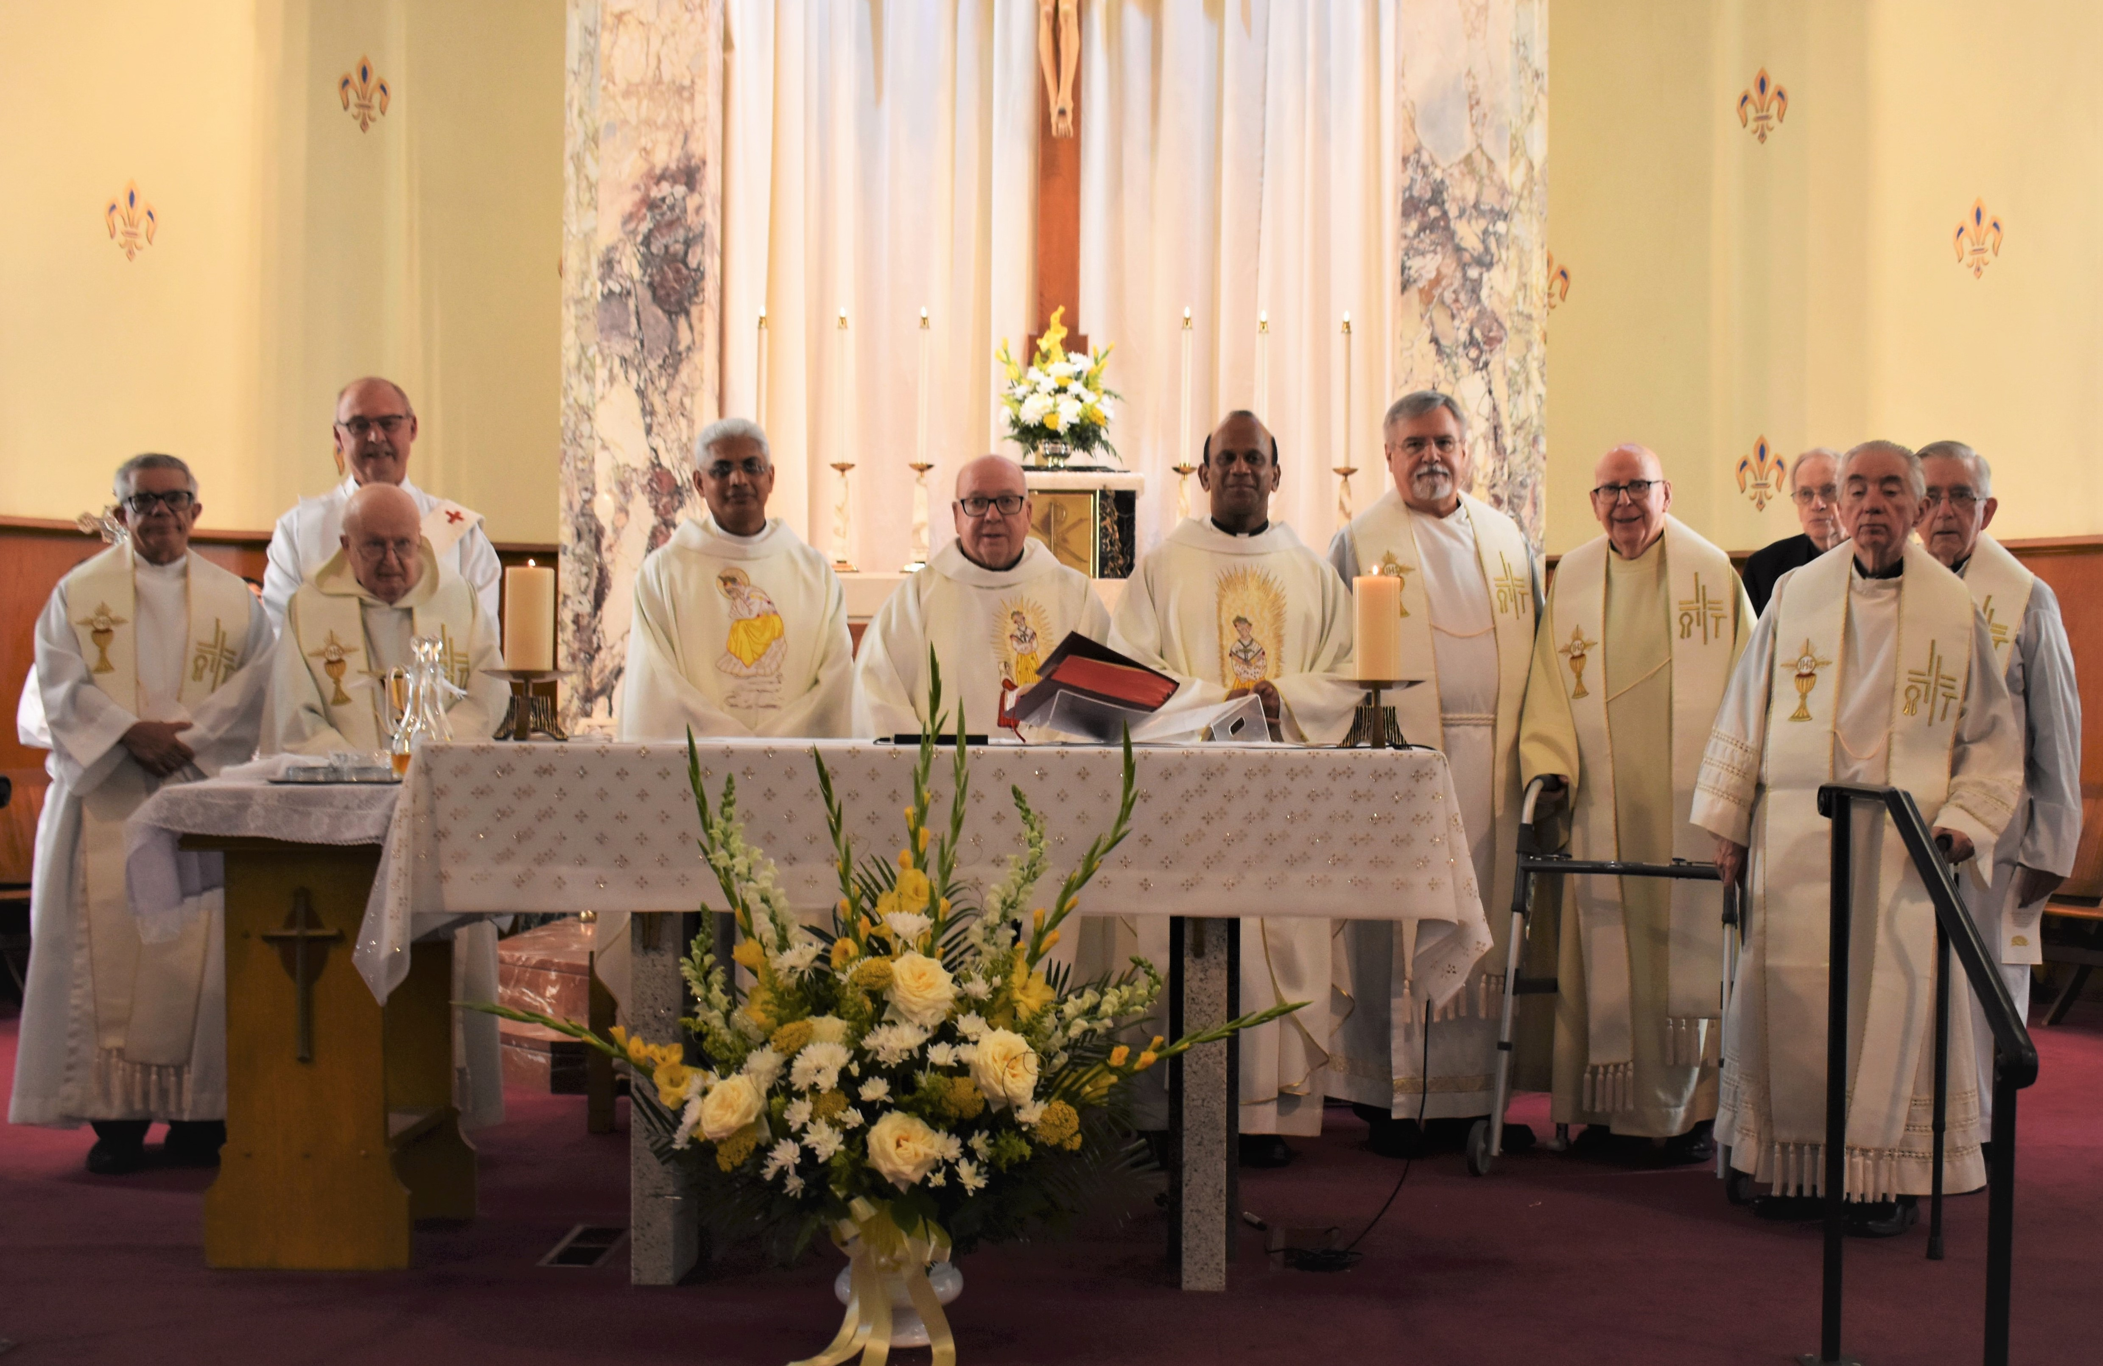

Golden Jubilee celebration of
Fr. Thomas Sickler, M.S

“Fr. John O’Neill Memorial Fund
Dear Parishioners and friends,
We all know the love Fr. John O’Neill, M.S. had for St. James School. The School had a place in his heart and he dedicated his life for the betterment of the school.
To honor Fr. John and for the continuous support of the school we have started a fund called, “Fr. John O’Neill Memorial Fund”. A new account has been opened for this special purpose. All those who would like to support St. James School please make your check payable to St. James Church and in the memo; please specify – Fr. John O’Neill Memorial Fund.
Thank you for your continued support, Fr. Roy

PARISH EVENTS
Wednesday – Devotion to the Infant Jesus of Prague
Every Wednesday at 8:30AM.
Rosary for Vocations - Tuesdays and Thursdays at 8.30AM.
Wednesday – Bingo in the Church Hall at 7PM.
Men’s Bible Study – Fourth Monday of every Month at 7PM in the Church Hall.
Holy Hour – Every Third Monday of the Month.
Our next Holy Hour is July 17, 2023.

THE VIGIL LIGHTS… are burning brightly in prayer for Fr. Rene Parent as he celebrates his Birthday on July 2nd.

MARIAN SHRINE FLOWER ARRANGEMENT…
The flower arrangement for our Holy Mother for the week of 7/01 is open to volunteers. The flower arrangement for the week of 7/9 is donated in memory of Richard Grenier by Marguerite and family.

WEEKLY OFFERING…..……….…..$5,803.00
7/2 – School Support
7/9 – Renovation Fund
Our Lady of La Salette Parish, Brooklyn
Adoration of our Lord
He gave the ultimate sacrifice for us! May we sacrifice one hour a week to be with Him? Visit Him during Eucharistic Adoration. There is always a need for faithful adorers. Please consider committing to a specific hour. Silent Adoration begins at 8.30 am following the 8.00 am Mass on Wednesdays and continues until 6.45 pm. Call the rectory for more information – 860-774-6275

Schedule for July 8th and July 9th
4:30PM 7:00AM
Celebrant: Fr. Rene Parent Fr. Roy Parayil
E. Minister: Sandra Lepine John Lupien
Louis Lepine Susan Griffiths(L)
Diane Charron
Ralph Oriola(L)

9:00AM 11:00AM
Celebrant: Fr. Rene Parent Fr. Roy Parayil
E. Minister: Stephen Houle MichelleBrady
Bev Richardson John Brady
Adam Brindamour(L) Erika Lorange(L)

MASSES
MONDAY, July 3, Saint Thomas, Apostle
9:00AM Arlene Morkis…by Alice Sears
9:00AM Ovila Charron…by family
TUESDAY, July 4, Independence Day
9:00AM Edward & Irene Stack…by Bev Richardson
9:00AM For all of our Veterans deceased and living
WEDNESDAY, July 5, Saint Anthony Zaccaria, Priest
Saint Elizabeth of Portugal
9:00AM John & Cheryl Boland…by the Miller children
9:00AM For our Parishioners
9:00AM Julia Szimanouskas…by family
THURSDAY, July 6, Saint Maria Goretti, Virgin & Martyr
9:00AM Lucien J. Desilets…Month’s Mind…by family
9:00AM For our Priests…by Cynthia Roberts
9:00AM Jamie Caron…30th Anniversary…by Ernie Caron
FRIDAY, July 7,
9:00AM Ben Desaulnier…by family
9:00AM Fr. John O’Neill…by Paul
SATURDAY, July 8, Blessed Virgin Mary
4:30PM Stephen & Henrietta Kuszaj…by family
4:30PM Aldo Cassettari…by daughter
SUNDAY, July 9, Fourteenth Sunday in Ordinary Time
7:00AM Lorina Grenon…by Paul Grenon
7:00AM Mary Egan…by David & Judy Rzucidlo
9:00AM Lillian & Alphonse Bisson…by estate
9:00AM Ted Magao (the Barber)…by Charlotte & Sean
11:00AM Cindy Aulie…by Scott & Phyllis Morrison
11:00AM Winona Skawinski…by Marcia & Brian Bardin

LASALETTE MASSES
In memory of Frederick & Adelyn Bodenschatz
In memory of David & Sophie Hovat by son, Joseph

2023 Masses Available:
4:30PM… 9/23; 9/30; 10/07; 12/30
7:00AM… 9/10; 9/17; 10/01; 10/08; 10/15; 10/22; 11/05; 9:00AM… 7/11; 8/02; 8/04; 8/11; 8/14; 8/15; 8/16; 8/17; 8/18; 8/21; 8/22; 8/23; 8/24; 8/25; 8/28; 8/29; 8/30; 9/05/9/06; 9/08;10/08; 11/05; 11/12; 12/03; 12/10; 12/24; 12/31.
11:00AM… 7/16; 7/30; 8/13; 9/10; 9/17; 9/24; 10/01; 10/08; 10/15; 10/29; 11/12; 12/3; 12/10; 12/17; 12/24; 12/31. There are still 9AM Weekday Mass openings available for the 2023 year. Please call or place intentions in the basket. We are now taking Mass intentions for the 2024 year. Please place Mass Intentions for weekdays & weekends in the collection basket. Please include a phone number. Mass stipends are 10.00

Banns of Ordination
The following men will be called to the
Order of Permanent Deacon on Saturday, July 8, 2023:

Mr. Joseph Delaney
Mr. Mark Desrosiers
Mr. Christopher Hammond
Mr. David Imhof
Mr. Ronald Krystofik
Should you know of any reason why these men should not be ordained Permanent Deacons
please write to:

The Most Reverend Michael R. Cote, Bishop of Norwich
201 Broadway
Norwich, CT 06360

SIGN-UP- SHEET FOR WEEK OF PRAYER AT HOME
The sign-up sheet for a week of prayer at home for vocations is at the main entrance of the church.
We humbly request all families to pray for vocations. Set aside a few minutes praying for vocations and inspiring our children at home. Please sign-up for a week of prayer. Those who sign up for the weekly prayer will dedicate themselves by praying the Rosary and Vocation Prayer from Sunday through Saturday. Let us continue to pray for an increase of vocations to the Priesthood and Religious life.
PRAYER AT HOME - The week of 7/01 – open to volunteers. The week of 7/8 – vocation prayers are offered by Richard Grenier and Ann, Maggie and family.

PRAYER FOR VOCATIONS…Loving and generous God, it is You who call us by name and ask us to follow You. Help us to grow in the love and service of our Church as we experience it today. Give us the energy and courage of Your Spirit to shape its future. Grant us faith-filled leaders who will embrace Christ’s mission of love and justice. Bless St. James parish by raising up dedicated and generous leaders from our families and friends who will serve Your people as Priests, Deacons, Brothers, Sisters and Lay Ministers. Inspire us to
Know you better and open our hearts to listen to Your call. We ask this through Christ our Lord… Amen. Our Lady of La Salette, Reconciler of Sinners, pray without ceasing for us who have recourse to You.

PRAYER TO ST. MICHAEL
St. Michael the Archangel, defend us in battle. Be our defense against the wickedness and snares of the devil. May God rebuke him, we humbly pray, and do Thou, O Prince of the heavenly host, by The power of God, thrust into hell Satan and all the evil spirits who prowl about the world seeking the ruin of souls. Amen.

S.O.S…SAVE OUR SCHOOL
St. James School wishes to thank Aida Bissonnette, Carol A. Marchesseault, Richard & Diane Allen, Pauline M. Caron and Roland & Judith Duprey for their generous donations in memory of Joy Chartier. We also want to thank Mr. & Mrs. Walter R. Payant, Jr. for their generous donation in memory of Peter Riel. We ask you to consider making a voluntary donation on the occasion of a death of a loved one (in lieu of flowers).

POURINGS AND PASSAGES BOOKSTORE… A used book store and coffeehouse is now open at 103 Main Street, Danielson, CT. Hours of operation are Wednesdays to Saturdays, 10AM to 5PM. The store is closed Sunday to Tuesday, holidays and snowy days. Please patronize, promote and support our bookstore. Net profits benefit St. James School. For more info, please call 860-774-1712, (Wednesdays to Saturdays) or leave a message. God bless you all! Jim

ATTENTION PARENTS WITH CHILDREN AGES 4-12
Are you interested in a great educational experience for your child?
IMAGINE a school where no grade has more than
30 students…
IMAGINE a school where you have the opportunity
to know the names of all the children in
your child’s class, and their parents…
IMAGINE a school where the values of
RESPECT & COMMUNITY SERVICE
are part of the curriculum…
IMAGINE a school where athletic programs and
other extra-curricular activities thrive…
IMAGINE a school with a focus on religious
education…
IMAGINE a school with convenient before and after
school programs…
IMAGINE this school is only minutes away in Danielson
Danielson
EXPERIENCE ST. JAMES SCHOOL – 860.774.3281

PARISHIONER REGISTRATION...if you are new to the Parish or have not yet registered we welcome you. Please fill out the form below and place it in the collection basket so our records can be updated.
PARISH UPDATE

NAME:_______________________________________

MAILING ADDRESS:___________________________

CITY/STATE/ZIP:__________________________

PHONE NUMBER:_____________________________
Check one: __I am a new parishioner
__I have an address correction to make
__I would like to receive weekly
envelopes

Diocesan News….
ANNIVERSARY MASS REGISTRATION –All couples married 25 & 50 years or celebrating any significant anniversary are invited to attend the 2023 Silver and Golden Jubilee Anniversary Mass celebrated by Bishop Michael R. Cote at the Cathedral of St. Patrick in Norwich on Sunday, September 10, 2023, at 2 P.M. Registration is required. To do so, send the following information: husband and wife’s name, address, telephone number, wedding date, anniversary being celebrated and parish to Mary-Jo McLaughlin, Catholic Family Services Coordinator, 199 Broadway, Norwich, CT 06360, call 860-848-2237, Ext 312, or email at mmclaughlin@norwichdiocese.net. The deadline for registering is Monday, August 14. This is a firm date, so please register early. Couples may also email a recent digital photo of themselves in a jpeg format to the email address to be included in a gallery of pictures on the Diocesan Website.

SIGN-UP TODAY FOR THE 2023 CLUB.
We appreciate your support. All proceeds benefit St. James School. Please sponsor new members so we can fill the club. Dues are only $20.00 for the remaining 4 drawings.
MONTHLY AWARDS: $2,000.00 in awards are given away each month…20 awards monthly, 240+ chances to win.
CHANGE OF ADDRESS: Please inform Kathy Hall (860)774-7635 of any address changes. Kathy is the “keeper of the records”.
OUR NEXT DRAWING WILL BE HELD ON SUNDAY, JUNE18TH, AT 8:30AM IN THE CHURCH HALL.
PLEASE SPONSOR A NEW MEMBER SO WE CAN FILL THE CLUB.
If you have any questions concerning dues etc. Please call Kathy Hall (860) 774-7635.

MARCH DRAWING
$1000 Kathy Hall 433 $25 Lucille Bernier 12 Door Prize: Janet Shay
300 Heather & Daniel Cregg 240 $25 Joseph Ashmore 23 Door Prize: Tammy Miner
200 Connor & Harper Depasse 463 $25 Valerie Barbeau 766
100 Cheryl Roberts 750 $25 Barbara Barrette 968
50 Amanda & Ryan Lajoie 253
50 Jean George Pelletier 580
$20.00 Winners are:
Gary Baker 246 Joan Daignan 742
Diane Landers 61 Barbara & Clyde Porter 250
Kerri & Joe Beaudreault 5 Cathleen Dunlop 432
Kathleen Gerardi 861 Jessica & Steven Pereira 364
Dorothea Couto 372 Rita LaBelle 346
__________________________________________________________________________________________________
APRIL DRAWING
$1000 David LaBelle 676 $25 Sheri & Joe Montecalvo 577 Door Prize: Joanne Wippert
300 Ron & Charlotte Litke 47 $25 John & Joan Lambert 153 Door Prize: Joan Lambert
200 Mickey Whittenburg 647 $25 Chris & Missy Mailhot 698
100 Donna Chevrette 489 $25 Richard Theriaque 157
50 Kim & Richard Brooks 178
50 Joan Fortin 634

$20.00 Winners are: Daniel Kimball 944
Margaret Burridge 200 Nancy Cole 589
Patti Noren 891 Diana Sorel 97
Sarah & William Nattress 587 Richard La Belle 461
Kristen Langlois 428 Bob & Lucille Farrell 736
Robert Dragon 314

REGISTRATION FORM - SPONSOR A NEW MEMBER TODAY SO WE CAN FILL THE CLUB
S.J.S.A. 2023 THOUSAND CLUB REGISTRATION FORM FOR NEW CLUB
Your choice of number if available___________(no guarantees)
SPONSORS NAME:________________________________
Please Print YOU DO NOT HAVE TO HAVE A SPONSOR TO JOIN THE CLUB

NAME:_______________________________________________________________PHONE:_________________

ADDRESS:____________________________________________________________________________________

CITY/TOWN:_______________________________________STATE:__________________ZIP CODE:______________
EMAIL:___________________________________________

